How to use GameLib

1. First, clone the GitHub repository
2. You will next get all the JavaFX files put into referenced libraries
3. Then go to run and debug and make a launch.json file
4. Within the file change the result of “mainClass” to the name of the class “GameLibraryApp”
5. Then under “projectName” make a new line called
6. “vmArgs”: –module-path (your files path to javafx-sdk library) –add-modules javafx.controls,javafx.fxml”
7. Go back to run and debug and in the top corner by the green play button change the selection from the current file to “App” and press run.

Once you are on the main screen you can view the library and press the add button to bring whichever game you want into the library section.

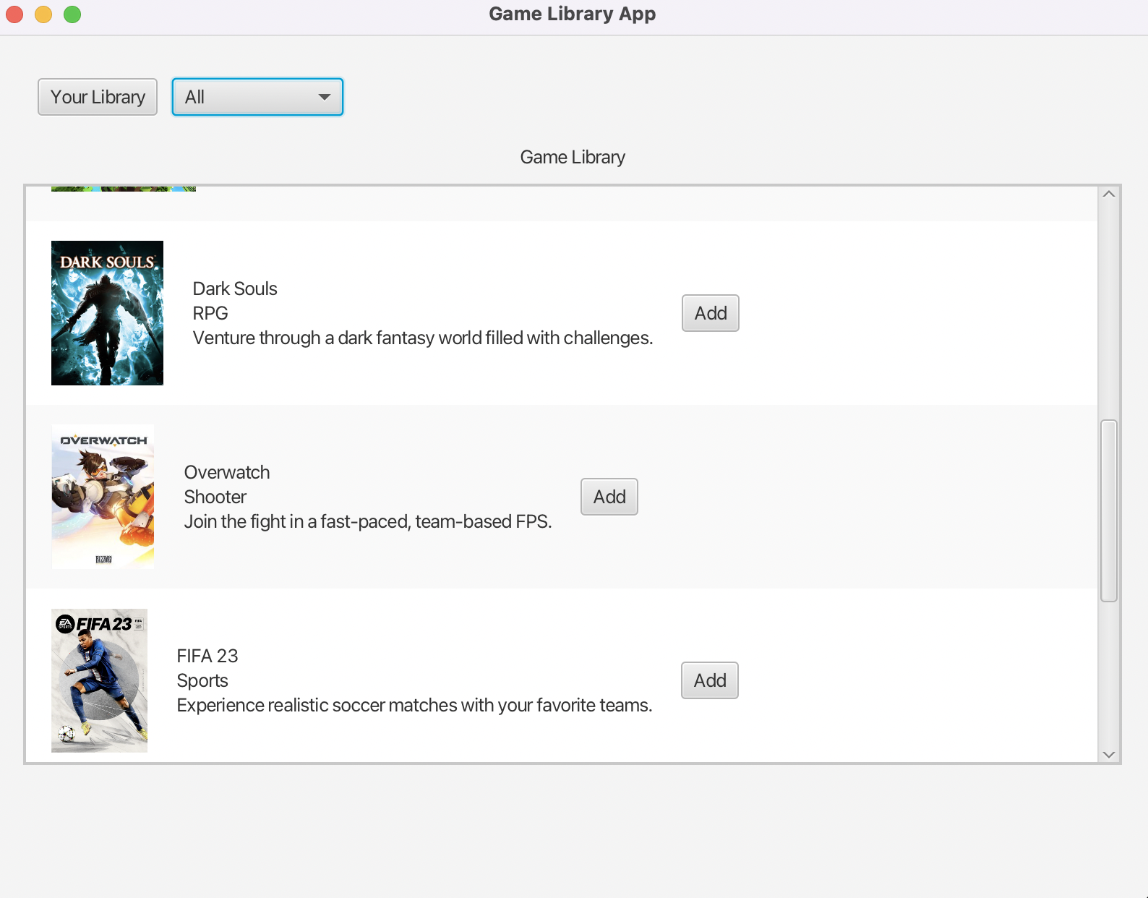

Once you add some games press the your library button to go onto the your library screen and view the games you selected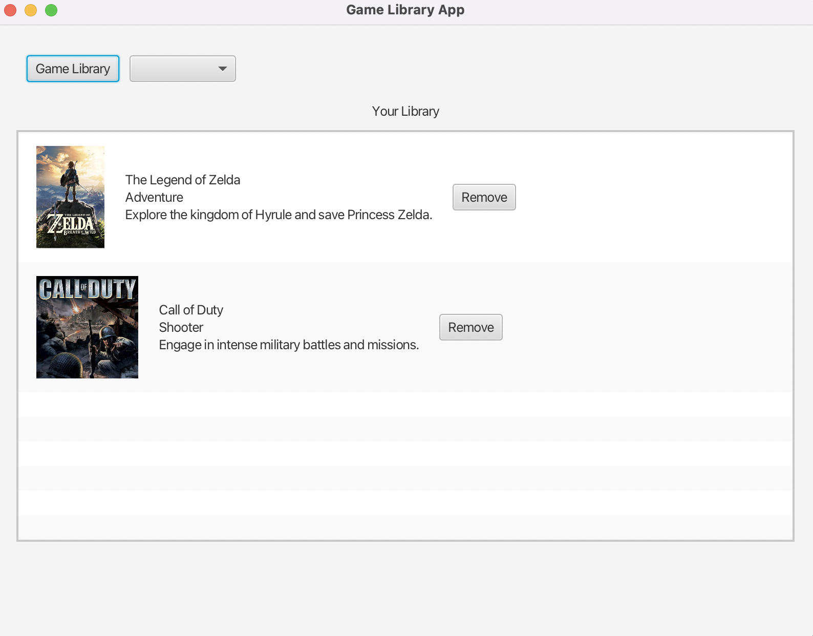

You also have the option to filter by genre on both libraries by simply clicking the dropdown box next to the game library or your library button and select the genre you want to view and the games under that genre will be listed